**HOW TO INSTALL ECLIPSE FOR HADOOP DEVELOPMENT**

Eclipse is a IDE used for mainly for java programming. MapReduce is a software framework associate with java programming, using which we can write applications to batch process huge amounts of data, terabytes or petabytes of data stored in Apache Hadoop. MapReduce is a core component of Hadoop. So, we need to install and configure eclipse for MapReduce.

In this tutorial, I will show you how to install and configure Eclipse for Hadoop development on Windows.

## **Prerequisites**:

* jdk-8u131-windows-x64
* eclipse-java-oxygen-R-win32-x86_64
* hadoop-2.8.1.tar.gz

Download Source:Paste the following link into web browser to download

https://drive.google.com/open?id=1WYIOJfupaq2X411KWEROJF1anAD5mfYQ

1. **Install Java**

We need to make sure Java is installed on Windows. If not, please click [*here*](http://docs.oracle.com/cd/E21454_01/html/821-2532/inst_cli_jdk_javahome_t.html#inst_cli_set_jdk_windows_t) for detailed instructions.



1. **Extract file eclipse-java-oxygen-R-win32-x86_64.zip**

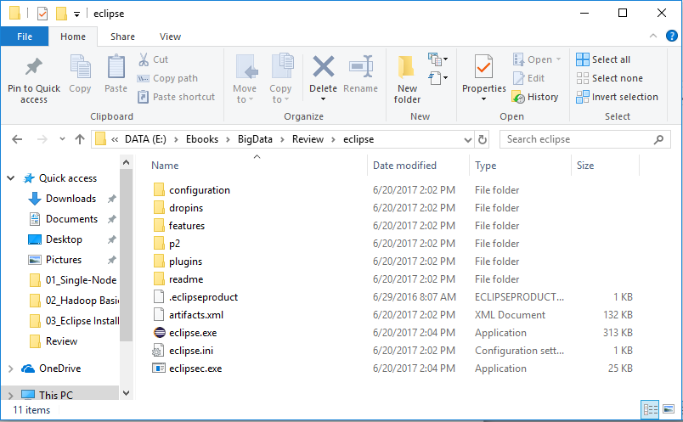

1. **Extract file hadoop-2.8.1.tar.gz**

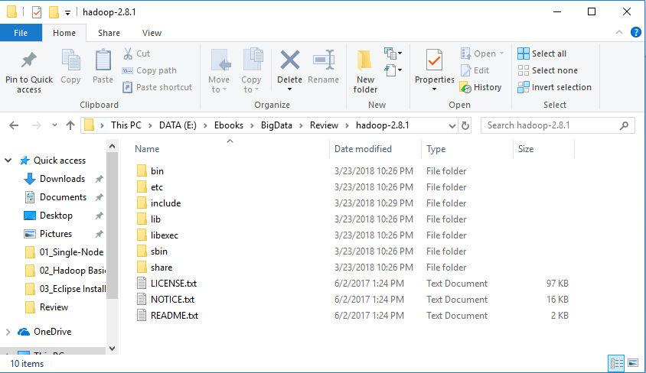

1. **Download Hadoop Eclipse plug-in at the following link**

<https://github.com/Ravi-Shekhar/hadoop-eclipse-plugin/blob/master/release/hadoop-eclipse-plugin-2.6.0.jar>

And copy it into **eclipse\plugins**

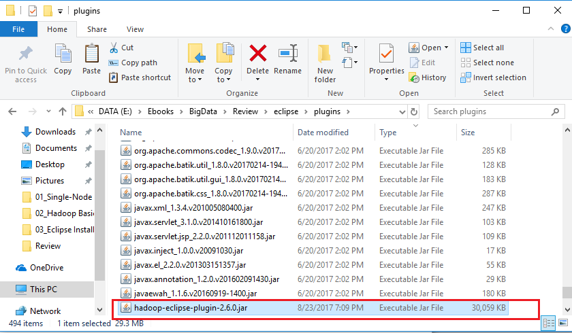

1. **Configure environment variables**

*JAVA_HOME=C:\Program Files\Java\jdk1.8.0_131*

*CLASSPATH=.;%JAVA_HOME%\lib;%JAVA_HOME%\lib\tools.jar*

*HADOOP_HOME= E:\Ebooks\BigData\Review\hadoop-2.8.1 HADOOP_USER_NAME=hadoopuser*

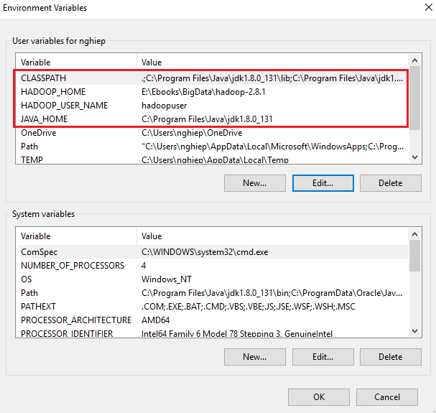

Edit PATH by adding this line at the end of line

*;%JAVA_HOME%\bin;%JAVA_HOME%\jre\bin;%HADOOP_HOME%\bin;*

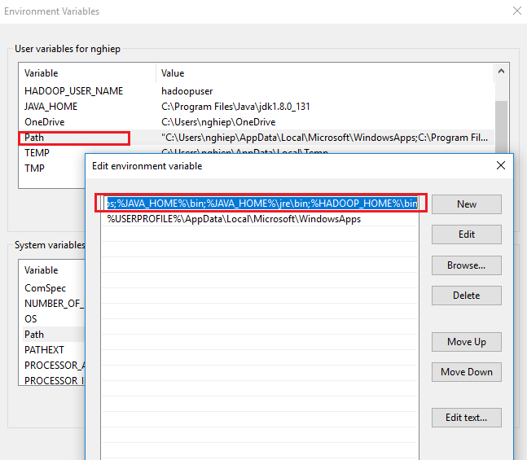

1. **Download winutils at the following link** <https://github.com/steveloughran/winutils/tree/master/hadoop-2.7.1/>

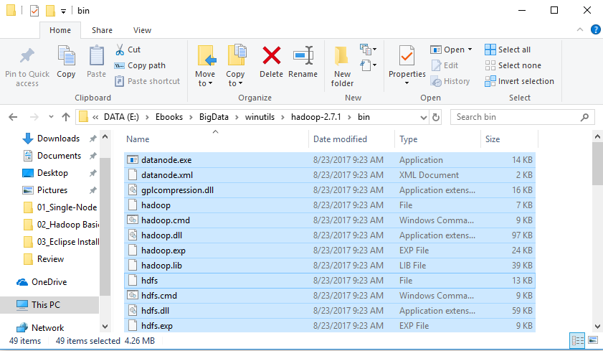

1. Copy all items into **C:\Windows\System32** and **hadoop-2.8.1\bin**

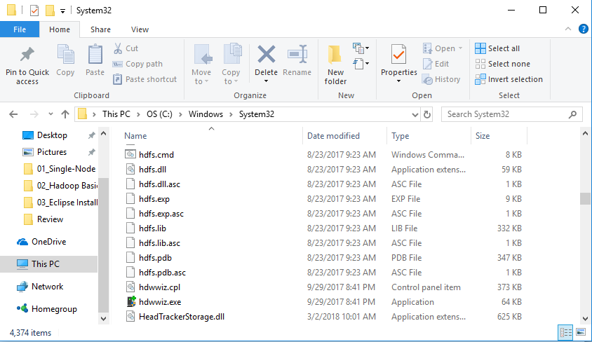

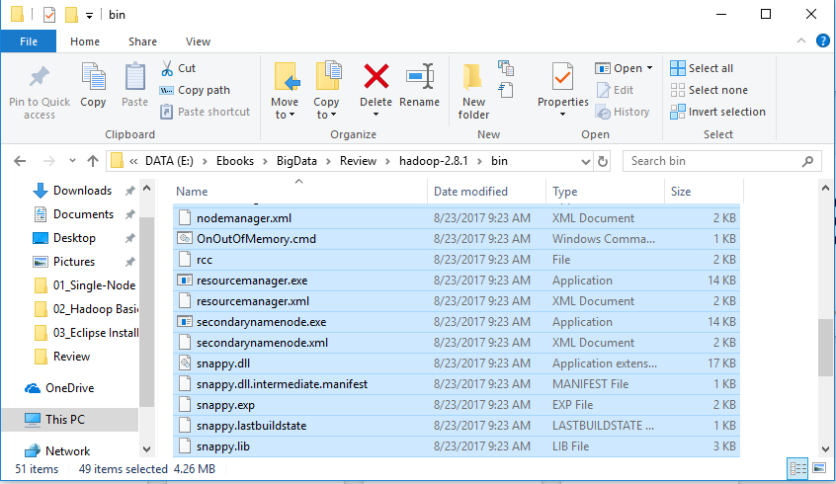

1. **Start Eclipse**



1. **Configure Hadoop installation directory**

Select **Window** -> **Preferences -> Hadoop Map/Reduce** and browse to Hadoop installation directory

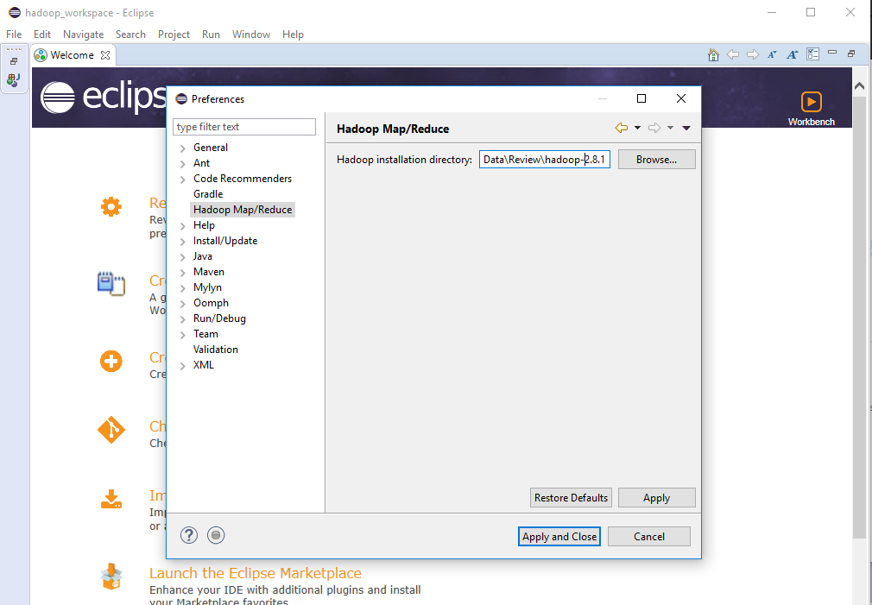

1. **Configure Map/Reduce location**

Select **Window** -> **Show View… -> Other…**

In **Show View** window, expand **MapReduce Tools** and select **Map/Reduce Locations**

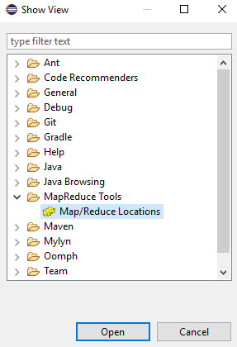

Click on **New Hadoop location…**

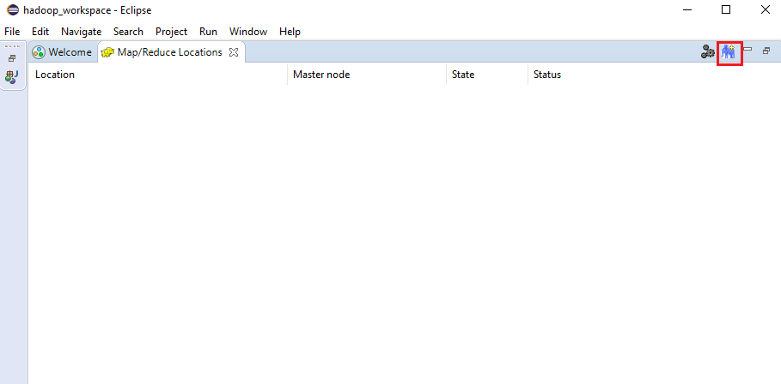

Enter **Map/Reduce(V2) Master** and **DFS Master**

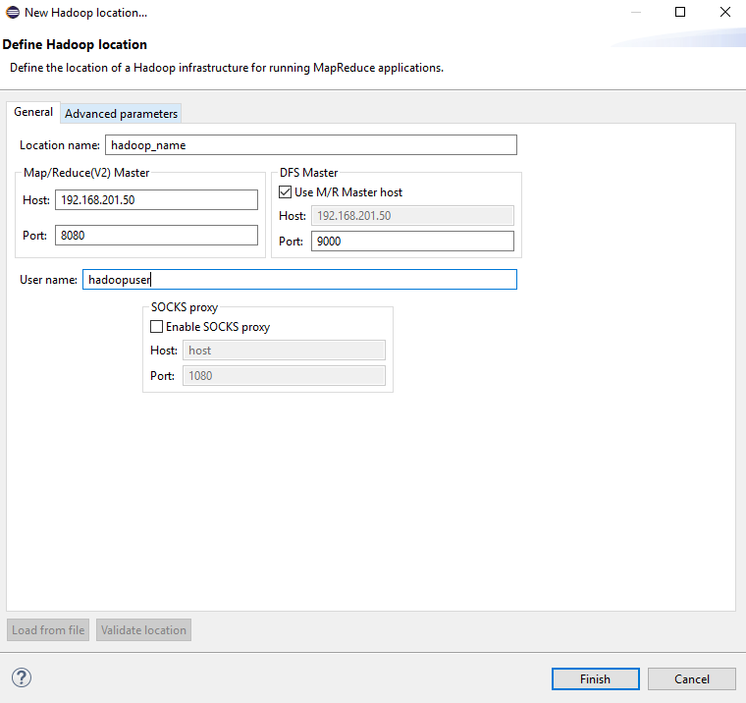

Click **Finish**

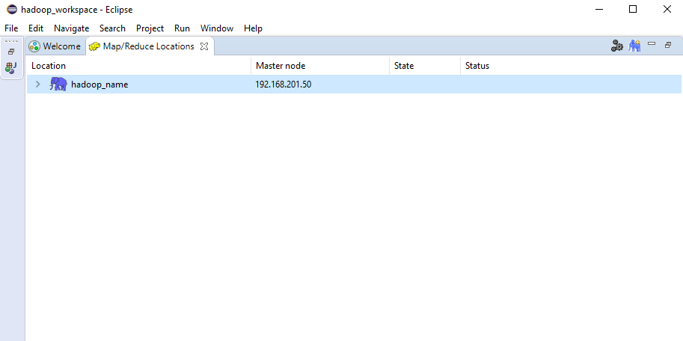

**☺ Note:**

* View **Map/Reduce(V2) Master** port in $HADOOP_HOME/etc/hadoop/yarn-site.xml

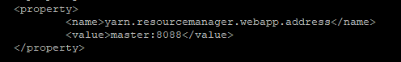

* View **DFS Master** port in $HADOOP_HOME/etc/hadoop/core-site.xml



1. **Test**

* Create folder in HDFS

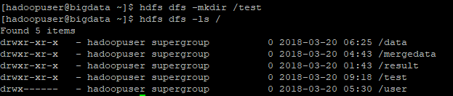

* Select **Window** -> **Show View** -> **Project Explorer**
* Double click on **hadoop_name** tab
* You view see **test** folder created in HDFS

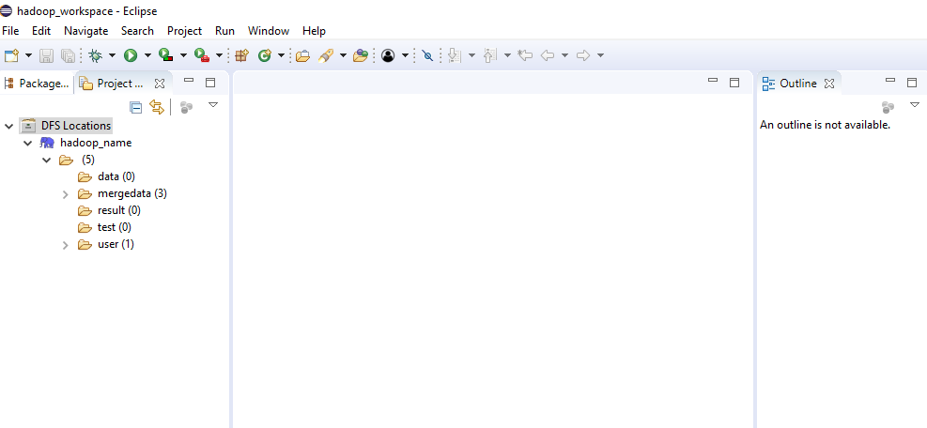

* Try to upload one file to HDFS: Right click on **test**, select **Upload files to DFS…**

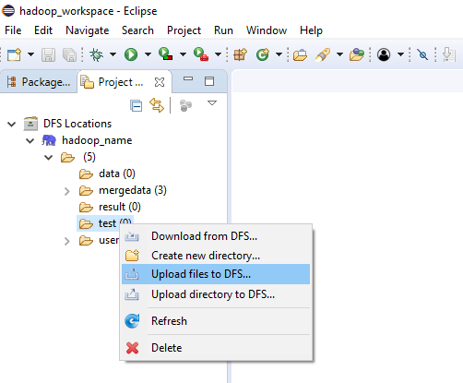

* Refresh to see the result

